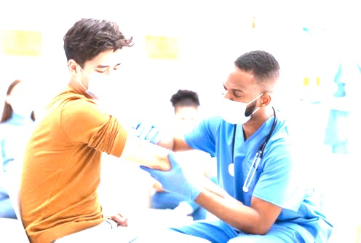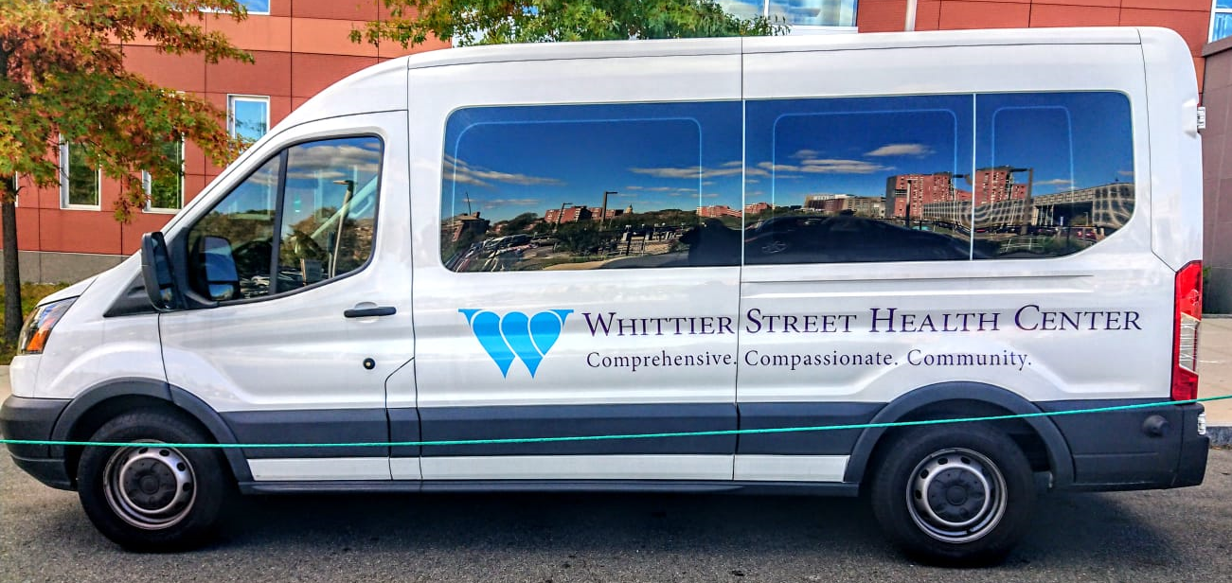 PARKWAY UNITED METHODIST CHURCH
&
WHITTIER STREET HEALTH CENTER
VAKEN KONT KOVID-19
POP UP KLINIK
Medi 21 Septanm 2021
11:00 AM to 4:30 PM
Parkway United Methodist Church
158 Blue Hills Parkway, Milton MA
617-989-3028
PAGEN RANDEROU KI NECESÈ
OUVÈ A TOUT MOUN

