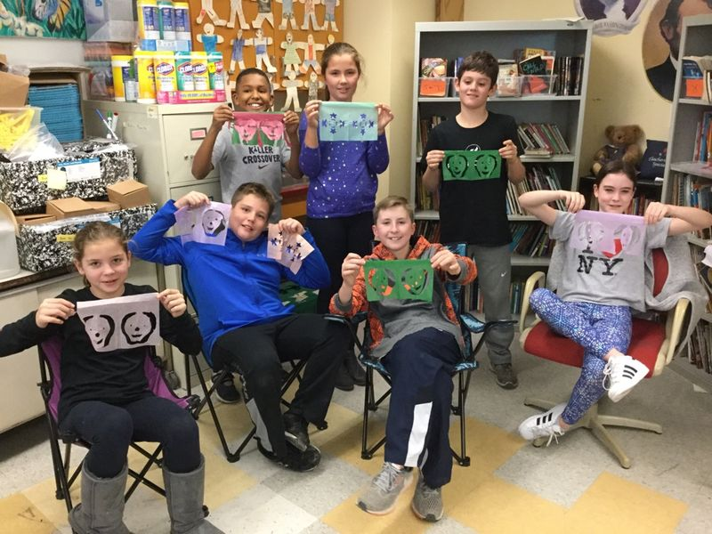 |  |  | - Noticias  The Elementary Spanish Newsletter
Fifth graders show off their Papel Picado for Día de los muertos. |  |  | Fourth grade Sugar skulls

Bienvenidos a la clase de español!
Señora Brown

We want to welcome the first grade families and new students to the Elementary Spanish Program. Our first graders are busy at work learning how to greet in Spanish, practicing colors, numbers, and learning seasonal songs.
The Second graders have been reviewing shapes and colors, practicing introducing themselves and learning to count to 50. They are also building reading comprehension and fluency skills. I hope they have been sharing their take- home libritos with you!
The Third graders are learning Spanish vocabulary related to the classroom, practicing counting objects, and making plurals. They are also learning to ask simple questions like “Who is that?” We celebrated Hispanic Heritage Month by learning about Luis Soriano and his Biblioburro. Students recently made masks for Día de los Muertos.
Our fourth graders are naming body parts and learning how to explain what hurts with the verb doler. They have also learned how to ask others if things hurt. We celebrated Hispanic Heritage Month by learning about the history of Hispanic Heritage Month and about famous Hispanics and their great contributions to the US and the world. Muchas gracias to the Glover PTO for funding our sugar skull craft as part of our learning about Día de los Muertos.
The Fifth graders are learning to ask and answer personal information questions and expressing likes and dislikes. Students will be presenting autobiographies very soon and are working on building paragraph-writing skills. We celebrated Hispanic Heritage Month by reading about famous Hispanic Americans of past and present whose great contributions have enriched the world of art, literature, music, politics, public service, medicine and athletics. We also recently made papel picado, paper decorations using symmetry for Día de los Muertos.
Other important Information
Third, fourth and fifth graders get weekly homework assignments. Be sure to check in with your child to ensure they are completing them.
Third, fourth and fifth graders also have online Spanish journals on Seesaw. If you have not yet connected to your child’s journal, please email me at cbrown@miltonps.org for instructions. Students and I post videos, projects, photos, and assignments on Seesaw to share with families.

Highly Engaging Spanish Apps for Elementary Kids
Looking for apps for your child to practice and enhance their Spanish learning at home? Click on the link below for a list of age appropriate apps and brief descriptions.
http://www.bestappsforkids.com/category/apps-for-education/language-apps/learning-spanish/

