o
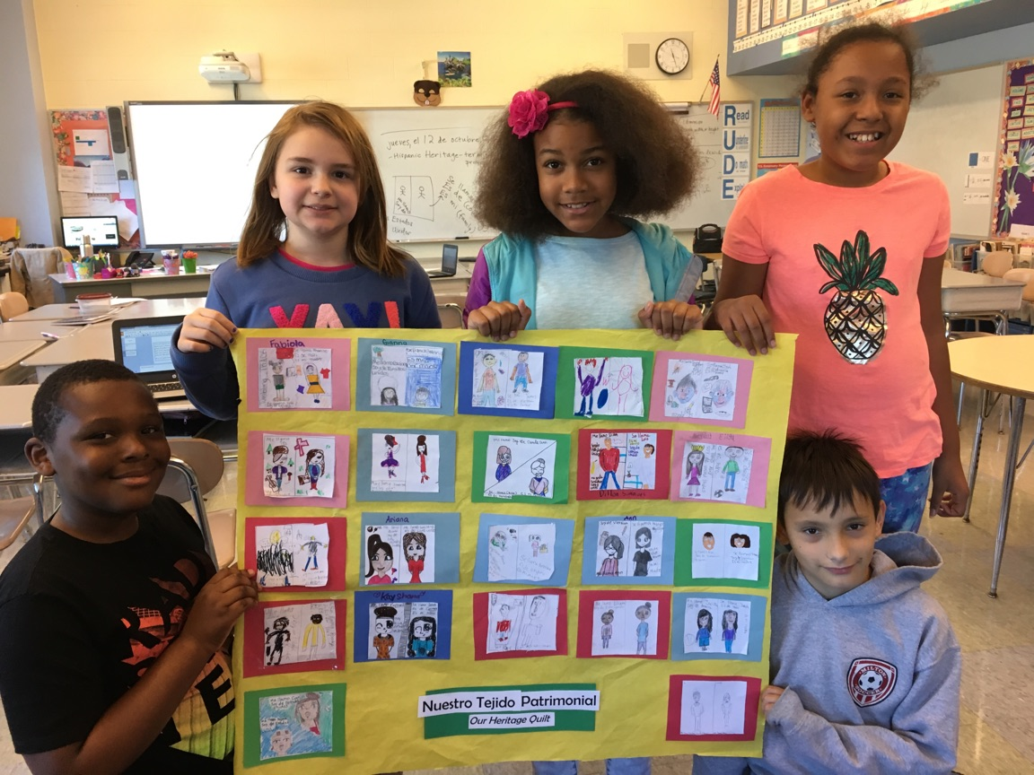 |  | - Noticias  - The Elementary Spanish Newsletter
grade 5 students showing their class’ heritage quilt ~ ‘nuestro tejido patrimonial’ |  | EN CASA (At Home):

I want to welcome the first grade families to the Elementary Spanish Program. Our first graders are busy at work learning how to say their name, numbers 1-20, colors, shapes and letters of the alphabet in Spanish.
Second graders have been reviewing shapes and colors, and learning to count to 50.
Third graders are labeling, counting, and measuring classroom objects. We are making mathematics connections this month as we analyze and categorize our findings about classroom objects in Spanish.
Our fourth graders are designing their own monsters to use body and face parts that they have learned. Students also compared and contrasted designs of Southwestern textiles and looked at some of Señora Taber’s textiles from Guatemala for Hispanic Heritage Month.
Fifth graders are learning four personal information questions in Spanish to be able to write their autobiography. They also interviewed family members to help create a class quilt to show Tucker families origins for Hispanic Heritage Month.

¡Bienvenidos a la clase de español!
by Señora Taber
Link to Practice Spanish at Home
123 Teach Me Spanish for Kids http://www.123teachme.com/learn_spanish/spanish_for_children

Our Journeys/ Our Stories
Nuestros Caminos/ Nuestras Historias
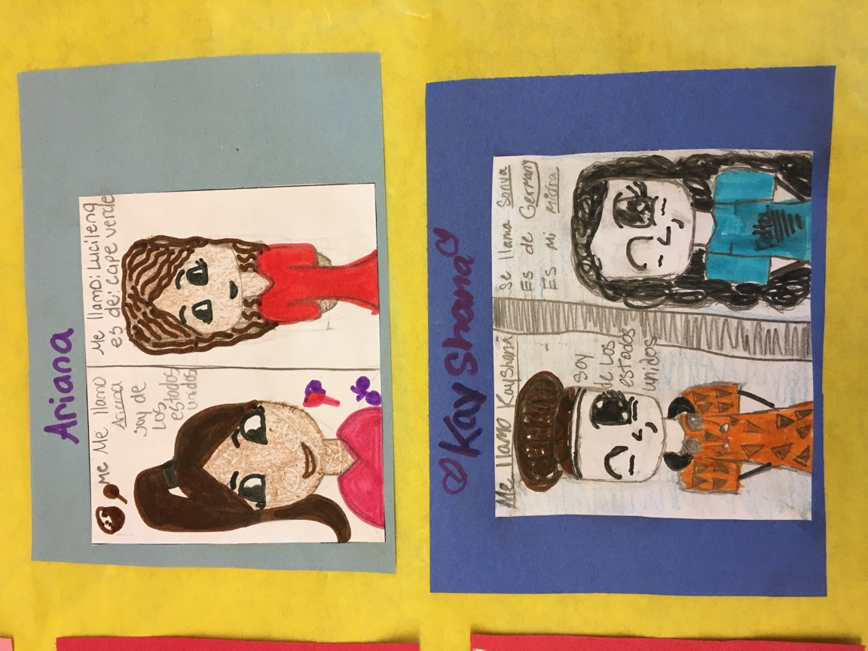
Click on the following link: Smithsonian Bilingual Family Guide
for questions and activities to learn more about your family and for inspiration to be a role model for someone special in your own life.

